**Noakhali Science & Technology University**

Department of Computer Science & Telecommunication Engineering

**ASSIGNMENT ON**

Data Structures and Analysis

**Submitted To:**

**Dr. Fateha Khanam Bappee**

Associate Professor,

Computer Science & Telecommunication Engineering, NSTU.

**Submitted By:**

**Mohammad Borhan Uddin**

Roll: ASH2101008M,

Session: 2020-21

Department: Computer Science & Telecommunication Engineering

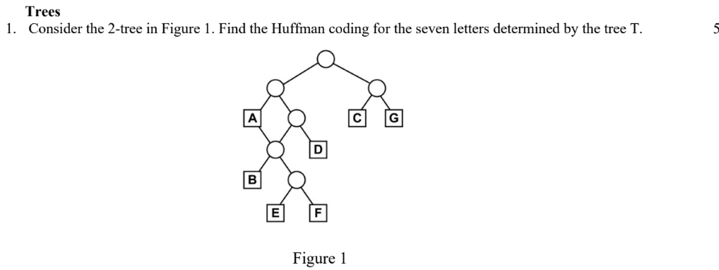Solution:

To find the Huffman code, we must create Huffman Tree first. Then, we can find the Huffman code by traversing the tree.

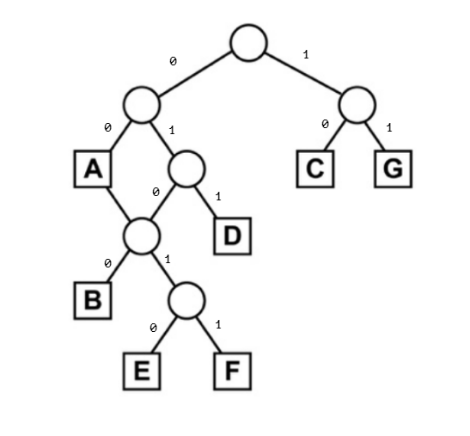

Figure : Huffman Tree

|  |  |
| --- | --- |
| Character | Code |
| A | 00 |
| B | 0100 |
| C | 10 |
| D | 011 |
| E | 01010 |
| F | 01011 |
| G | 11 |



Solution:

We know,

$$Weighted path length =\sum_{i=1}^{n}{(}{\text{Path Length}}_{i}*{\text{Weight of Node}}_{i})$$

Where, Path Length is also considered as Level

We redraw the tree for our solving purpose.

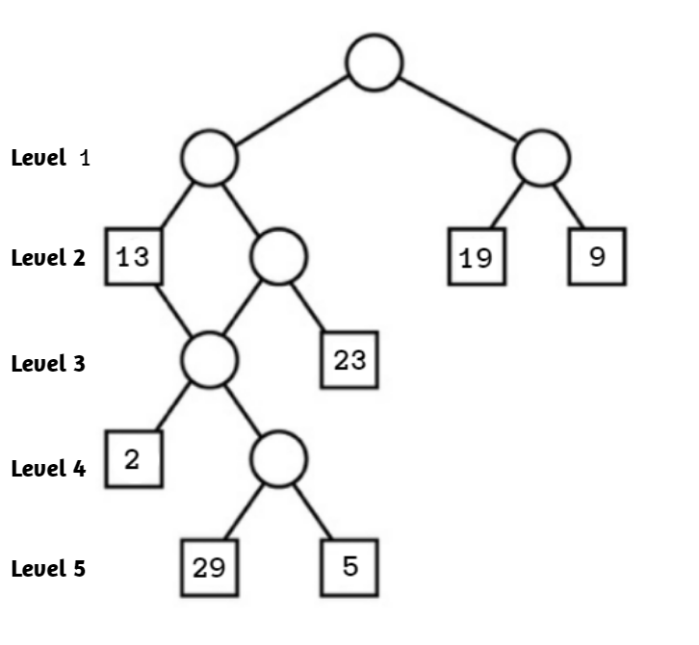

Figure : Figure 1 with Data

$Weighted Path length =13*2+23*3+2*4+29*5+5*5+19*2+9*2$ $=329$

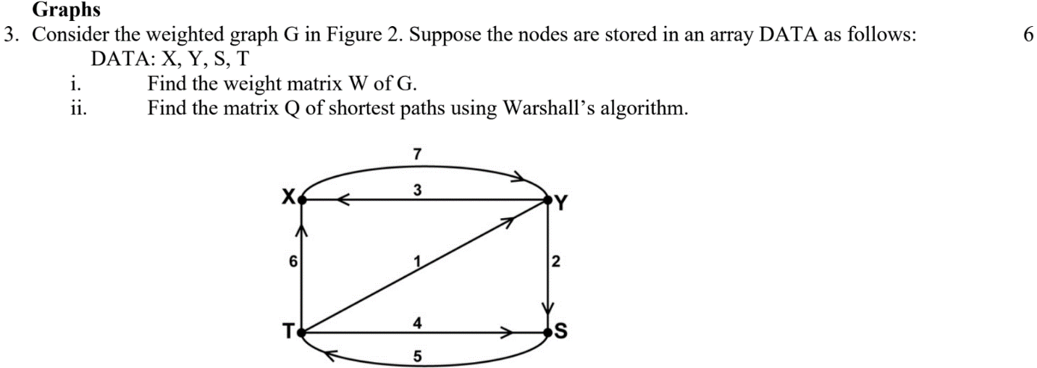Solution:

(i) Find the weight matrix W of G.

The directed graph view below:

We’ll use 0 if there’s no edge between the nodes. Otherwise, we’ll put the weight of the edge between the nodes.

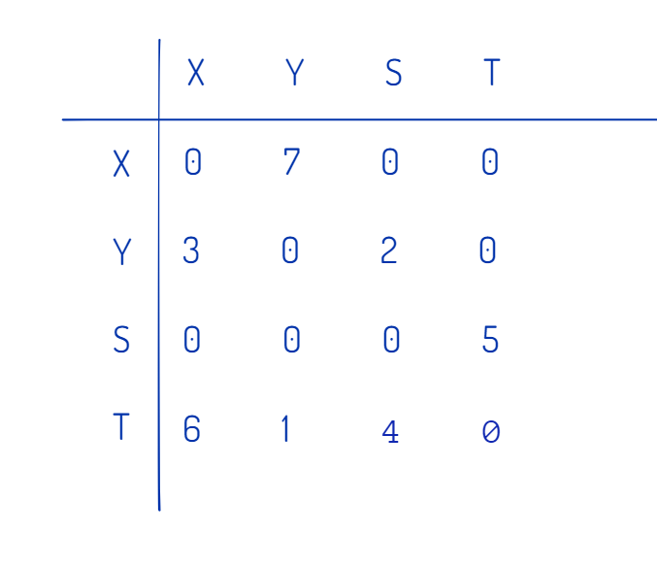

The adjacent matrix:

W = $\left[\begin{matrix}0 & 7 & 0 & 0 \\ 3 & 0 & 2 & 0 \\ 0 & 0 & 0 & 5 \\ 6 & 1 & 4 & 0\end{matrix}\right]$

(ii) Find the matrix Q of shortest paths using Warshall’s algorithm.

Floyd-Warshall Algorithm is an algorithm for finding the shortest path between all the pairs of vertices in a weighted graph.

**Steps:**

For a graph with N vertices:

**Step 1:** Initialize the shortest paths between any 2 vertices with Infinity.

**Step 2:** Find all pair shortest paths that use 0 intermediate vertices, then find the shortest paths that use 1 intermediate vertex and so on. until using all N vertices as intermediate nodes.

**Step 3:** Minimize the shortest paths between any 2 pairs in the previous operation.

**Step 4:**For any 2 vertices (i,j) , one should actually minimize the distances between this pair using the first K nodes, so the shortest path will be: *min(dist[i][k]+dist[k][j],dist[i][j])*.

Let,

The initial matrix be

$D=$ $\left[\begin{matrix}0 & 7 & ∞ & ∞ \\ 3 & 0 & 2 & ∞ \\ ∞ & ∞ & 0 & 5 \\ 6 & 1 & 4 & 0\end{matrix}\right]$

$D^{1}=$ $\left[\begin{matrix}0 & 7 & ∞ & ∞ \\ 3 & 0 & 2 & ∞ \\ ∞ & ∞ & 0 & 5 \\ 6 & 1 & 4 & 0\end{matrix}\right]$

$D^{2}=$ $\left[\begin{matrix}0 & 7 & 9 & ∞ \\ 3 & 0 & 2 & ∞ \\ ∞ & ∞ & 0 & 5 \\ 4 & 1 & 3 & 0\end{matrix}\right]$

$D^{3}=$ $\left[\begin{matrix}0 & 7 & 9 & 14 \\ 3 & 0 & 2 & 7 \\ ∞ & ∞ & 0 & 5 \\ 4 & 1 & 3 & 0\end{matrix}\right]$

$D^{4}=$ $\left[\begin{matrix}0 & 7 & 9 & 14 \\ 3 & 0 & 2 & 7 \\ 9 & 6 & 0 & 5 \\ 4 & 1 & 3 & 0\end{matrix}\right]=Q$

Where Q is the Shortest Path Matrix.

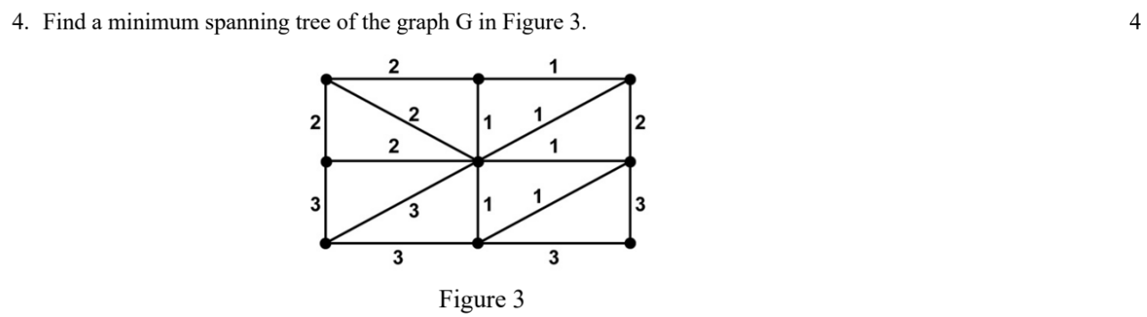

Solution:

Minimum spanning tree can be defined as the spanning tree in which the sum of the weights of the edge is minimum. The weight of the spanning tree is the sum of the weights given to the edges of the spanning tree.

We will use **Prim’s Algorithm** to find the Minimum spanning tree of the graph.

**Steps:**

* First, we must initialize a Minimum Spanning Tree with the randomly chosen vertex.
* Now, we must find all the edges that connect the tree in the above step with the new vertices. From the edges found, select the minimum edge, and add it to the tree.
* Repeat step 2 until the minimum spanning tree is formed.

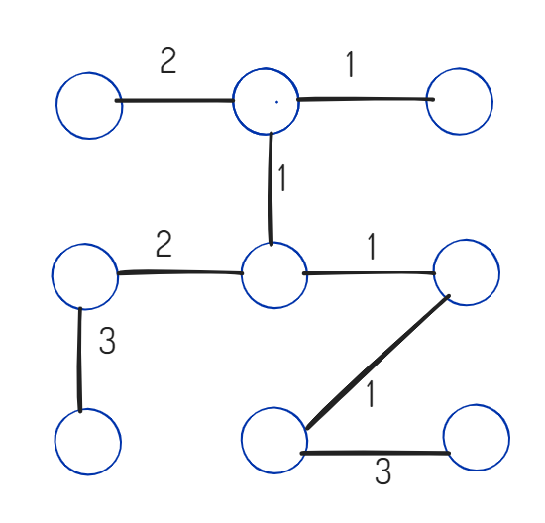

The minimum spanning tree of the graph is correct because:

It is weighted

It is connected

It has no cycle

It is undirected

Figure : Minimum Spanning Tree

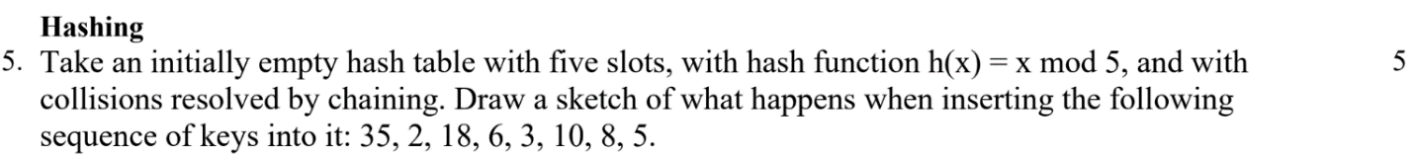Solution:

The provided hash function $h\left(x\right)=x mod 5$

$$35\%5=0 \\ 2\%5=2 \\ 18\%5=3 \\ 6\%5=1 \\ 3\%5=3 \\ 10\%5=0 \\ 8\%5=3 \\ 5\%5=0$$

Since the hash table uses chaining to resolve collisions, the keys are stored in linked lists at each slot. When a key is inserted and there is already a key at the slot, the new key is added to the end of the linked list at that slot.

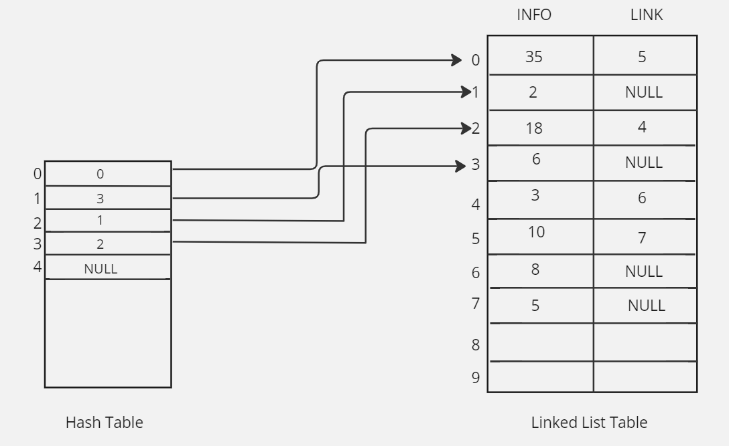

Figure : Hash Table & Linked List